Software Requirements Specification
for
‘Scrumptious’ - Personal Finance website
Version 1.1 approved
Prepared by:
Scrumptious six
1st April 2018
Table of Contents
Table of Contents ii
Revision History ii
1. Introduction 1
1.1 Purpose 1
1.2 Intended Audience and Reading Suggestions 1
1.3 Product Scope 2
2. Overall Description 2
2.1 Product Perspective 2
2.2 Product Functions 2
2.3 User Classes and Characteristics 2
2.4 Operating Environment 3
2.5 Design and Implementation Constraints 3
2.6 User Documentation 3
2.7 Assumptions and Dependencies 3
3. External Interface Requirements 4
3.1 User Interfaces 4
3.2 Software Interfaces 4
3.3 Communications Interfaces 4
4. System Features 4
4.1 Secure account creation and login 4
4.2 Creating a financial account on the website 5
4.3 Uploading bank statements 5
4.3.1 Description and Priority 5
4.4 Scheduling payments/income 6
4.4.1 Description and Priority 6
4.5 Sending and receiving money 6
4.5.1 Description and Priority 6
4.6 Maintaining a Scrumptious online account 7
4.6.1 Description and Priority 7
4.7 Investments page 7
4.7.1 Description and Priority 7
4.8 Financial Analysis page 8
4.8.1 Description and Priority 8
5. Other Nonfunctional Requirements 8
5.1 Performance Requirements 8
5.2 Security Requirements 8
5.3 Software Quality Attributes 8
6. Appendix A: Analysis Models 9
6.1 Sequence diagram 9
6.2 Register User Sequence Diagram 10
6.3 Activity Diagram 11
6.4 UML Class Diagram 12
6.5 Use Case Diagram 13
7. Appendix C: To Be Determined List 14

Revision History
Name | Date | Reason For Changes | Version
D.K. | 9th February | New version developed | ALPHA
D.K. | 9th March | New Design Features added | BETA
D.K | 20th March | New Design Features added | Version 1.0
D.K | 1st April | New features added and code refactored | Version 1.1

Introduction

Purpose
This document serves as a comprehensive documentation for the ‘Scrumptious’ Personal Finance website. This is the refactored version of the product release so this documentation will include details about all the currently developed requirements.

Intended Audience and Reading Suggestions
This document is intended for a variety of reading audiences as it is intended to comprehensively give an outline of the requirements and specifications of the Scrumptious Website. Readers are encouraged to read the document from a ‘natural’ flow i.e. beginning at the introduction and following on to the end of the document. However, there are sections that may be skipped by certain users as they may not be as relevant to them; below is an outline of the most relevant parts of this document for each type of reader. (This is however only a suggestion and certain readers may wish to read the whole document for a comprehensive understanding of the website).

Developers
This set of audience will benefit greatest from reading the entirety of the document as in the case of making any revisions/updates it is important to understand why certain specifications were made and to have an in-depth understanding of the way the website was designed at a high level.

Project Managers
This set of audience will also benefit the most from reading the entirety of the document to understand the rationale behind the design of the website and the overall scope of the website.

Marketing staff
These readers are recommended to read the overall description and system features sections of the document as these will give the most information about the features and uses of the website which will be useful from a marketing perspective. The non-functional requirements page is also recommended for reading particularly the section on security as this is a highly important aspect of the website for advertising to users.

General users
This documentation is not explicitly designed to be read by general users as it is not intended to be a ‘user manual’ nor piece of advertising for the website. Nonetheless an interested user may find it useful to read to understand the overall design of the ‘Scrumptious’ website, for this purpose the overall description followed by the system features and the non-functional requirements should suffice.

Testers
This set of audience are recommended to focus their reading on the overall design, the system features and the non-functional requirements. These sections will give the most pertinent information for testers who can then check to ensure that the website is fully functional and secure.

Documentation Writers
These readers are encouraged to read the entirety of the document to gain a full and comprehensive understanding of the website before beginning to write any form of documentation.

Product Scope
The software specified herein is the ‘Scrumptious’ Personal Finance website. The purpose of this website is to simplify the process of managing personal finances giving users a quick and easy way to check their balances and savings, pay bills and manage expenditure. The overarching goal therefore is to ‘ensure that all users can manage their personal finance with simplicity and ease regardless of their chosen financial institution’.
This website is the core business operation of the Scrumptious Ltd group, it is therefore designed with the objective of being easily and quickly scalable as the company grows and to provide a constant and reliable stream of revenue for the company.

Overall Description

Product Perspective
This product was created for the Scrumptious group as a new self-contained product. It therefore has no existing system dependencies. All code was built from scratch and this is still a developing version of the website.

Product Functions
- View balances from a variety of institutions
- View section with income/expenditure flow
- View breakdown of expenditures (bills, groceries, rent…) on a monthly/yearly basis
- Section to allow payment of bills
- View Investment information
- Schedule bill payments/income
- Send/receive money from other users

User Classes and Characteristics
The 2 main users that shall use this product will be composed of include: general users, and administrators.

The ‘general users’ class is quite general and refers to anyone who uses the website for the general management of their personal finances. This will be people between 16-30 who are either just learning how to manage their finances or have some experience managing their finances. They should have functionality within the website to view their account balances and transactions; send money from one account to another and have contact information to their financial services account.

The Administrators will have the ability to manage user accounts by approving significant changes e.g. closing the account or closing an account with a financial institution. They will also be in charge of the maintenance of the website and updating content.

Operating Environment
The software is designed to operate on Google chrome and Mozilla Firefox web browsers at it’s best, though it should also work with other web browsers. It uses the concept of ‘graceful degradation’ to work with web browsers that use older versions of HTML or CSS.
The software is also designed with phone use in mind so that it may also be easily used via a mobile phone ‘on the go’.
The Primary software versions used when designing this project include: HTML5, CSS3.
The database hosting of this project is managed by an external provider- ‘GoDaddy’.

Design and Implementation Constraints
Due to time and capacity constraints the developers were unable to test the initial version with all screen sizes and phone web browsers. However, a wide variety of devices were used in the testing phase which gives us confidence that the website will be functional on majority of user’s devices.

User Documentation
User help will be a built-in component of the website where uses can easily either search for help with navigating the website or quickly browse through frequently asked questions. A user manual will also be provided upon request which users can look through to gain a better understanding of how to use the website.

Assumptions and Dependencies
As this is a website it will be fully dependent on the versions of CSS and HTML being run by the browsers, the database will be SQL based and will be hosted externally. The current versions have been used when designing and creating this website however those may change which could affect the running of the website. To ensure that the website is not affected by any browser upgrades/downgrades, the website will be constantly updated to ensure that it runs smoothly regardless of any changes on the browser level.

External Interface Requirements

User Interfaces
The main interface will be the user screen on the device (Phone, tablet, PC…) that they use to access the website. The design for this will need to take into account the possibility of a touchscreen use vs a mouse/keyboard use.

Software Interfaces
The website will need to work with a variety of browsers, which may have different versions of HTML and CSS. To ensure functionality on all browsers the principle of graceful degradation has been used in the design process. The website is also designed to be functional with or without JavaScript enabled.

Communications Interfaces
This website shall need to communicate with the users via both internal messages and email. In the case of email communication, the email shall be sent via HTTPS to ensure its security from our end however as we cannot guarantee that it will be securely accessed by the user emails will only contain update information and not any sensitive information (functionality to send notifications to user has not yet been implemented).An example of an email sent to a user is when the user forgot their password and need to reset it.
In the case that sensitive information needs to be sent to a user, this will be done through an internal message from within the website which will be encrypted. Currently this is not necessary and all updates to users are simply on their homepage.
The website will also have HTTPS encryption to ensure its authenticity and in turn its security.
(Browser requirements have already been mentioned, Section 2.4 Operating environment).

System Features

Secure account creation and login
4.1.1 Description and Priority
This high priority feature is required to enable users of the website to create an account which securely stores their information in relation to the personal finance website. Each user will also be required to provide a username and password to allow for a secure login to the website.
4.1.2 Stimulus/Response Sequences
The user actions for this will be simple on the homepage for the website the user will be prompted by a button to either ‘login’ or ‘sign-up’ depending on whether they are an existing user or not they will select the correct option and from there be directed either to a login page where they can provide their username and password to securely login or to a sign-up page where they can provide their details to create an account.
4.1.3 Functional Requirements
REQ-1: Provide personal details (email address, physical address, username and password) when creating an account
REQ-2: Prompt to user to provide username and password to login
REQ-3: Secure storage of personal details i.e. encryption to protect sensitive user information
REQ-4: 2 factor authentication method for users (Pending)

Password reset/recovery
4.2.1 Description and Priority
This is a high priority feature that allows users to re-gain access to their account after forgetting their password.
4.2.2 Stimulus/Response Sequences
To initiate this the user will select ‘forgot password’ from the login page. From there the user will go on to a page which requests for their Username and email address. After providing these and selecting ‘submit’ the user will be taken to a page requesting for their temporary access code which will be sent to them via an email. They will then key this in and thereafter be taken to a password reset page where they can reset their password and using that login to their account.
4.2.3 Functional Requirements
REQ-1: Ensure that the username and email provided in the ‘password reset’ form belong to an existing user
REQ-2: Generate a temporary one-time access key for users to use to reset their account password
REQ-3: Email the temporary one-time access key to the user.
REQ-4: Allow the user to reset their password after keying in the temporary access key and from there log in to their account.

Creating a financial account on the website
4.3.1 Description and Priority
This is a high priority feature to enable users to create a profile on the website of their current financial account (bank, credit card company, credit union…). This will help them manage their finances for that account in particular.
4.3.2 Stimulus/Response Sequences
From the overview page the user may go to the ‘Accounts’ page (option in toolbar) and from there create a new online account for their financial account. They will be prompted to enter details such as: ‘Title’- this identifies the account; ‘Institution’- here the user chooses the financial institution this account is linked to from a list of financial institutions; ‘Type’- here the user chooses the type of the account from a drop-down menu; ‘balance’- from here the user enters the balance currently in that account.
4.3.3 Functional Requirements

REQ-1: Secure storage of user financial account information (account balance, financial institution name, account type).
REQ-2: Creation of multiple accounts for one user.
REQ-2: Creation of different types of accounts for a user.

Uploading bank statements

4.4.1 Description and Priority
This is a high priority feature allowing users to upload their bank statements onto the banking platform to then update the balance in their account.
4.4.2 Stimulus/Response Sequences
To do this from the homepage (after logging in) the user will go to the ‘bank statements’ page and from there will be able to upload a bank statement from a ‘.csv’ file, they can name this statement and must link it to an account when uploading the statement. The user then selects ‘save’ to complete the upload.

4.4.3 Functional Requirements

REQ-1: Interpret .csv bank statement files and read into website to add transactions to the account profile.
REQ-2: Handle errors where the .csv file is not in the correct format by alerting the user.
REQ-3: Ability to later download bank statements as a ‘.csv’ file
REQ-4: Reconcile payments on .csv with scheduled payments set.
REQ-5: Display updated bank account transactions.

Scheduling payments/income

4.5.1 Description and Priority
This is a medium priority feature allowing users to schedule payments with either automatic payments or payment reminders and also to schedule income from their job(s).
4.5.2 Stimulus/Response Sequences
To do this the user will select the ‘calendar’ from the toolbar in their homepage and from there they will be able to add the type of payment choosing whether it will debit or credit the account with the amount; give the set frequency (monthly, bi-weekly…).

4.5.3 Functional Requirements
REQ-1: Save details of scheduled debit/credit securely
REQ-2: Option to edit/delete scheduled payment
REQ-3: Option to add notification to payment

Sending and receiving money

4.6.1 Description and Priority
This is a medium priority feature allowing users to send and receive money through the website platform. The money will be sent from their online wallet this ensures that the security of their account with a financial institution is not compromised. This will however be securely stored on the website.
4.6.2 Stimulus/Response Sequences
To do this the user will click on the ‘send money’ button from their account homepage and from there fill in the details of who they would want to send the money to (Website username, first/last name, email address) and from which account. The system will then issue instructions to debit the money from the users Scrumptious online account and send the money to the appropriate account.

4.6.3 Functional Requirements

REQ-1: Accept details of the transaction including: account details (website username, first name, last name, email address) that the money should be sent to; date that the money should be sent.
REQ-2: Confirmation that the money has been sent successfully and alert if it is not.
REQ-3: Secure transaction to prevent fraud (ask for user authentication before sending money)
REQ-4: Secure transaction in case money is not debited from online Scrumptious account.

Maintaining a Scrumptious online account

4.7.1 Description and Priority
This is a high priority allowing users to maintain an online wallet where they can make payments quickly and directly from the Scrumptious website.
4.7.2 Stimulus/Response Sequences
To do this the user will login to their Scrumptious account and from the homepage select their username from the top right corner which has their account balance.
4.7.3 Functional Requirements

REQ-1: Display account balances in a table format
REQ-2: Secure payments/money transfer feature (detailed in feature 4.5 sending and receiving money.
REQ-3: Secure storage of account information.

Investments page

4.8.1 Description and Priority
This is a medium priority feature that allows a user to gain some Investment advice from the website. It contains headlines and links to relevant news articles that shall be updated by an administrator.
4.8.2 Stimulus/Response Sequences
To do this the user will log into their Scrumptious account and from their homepage select the ‘Investments’ option from the toolbar.
4.8.3 Functional Requirements

REQ-1: Display relevant investment articles to improve users’ financial literacy

4.9 Financial Analysis page

4.9.1 Description and Priority
This is a medium priority feature that allows a user to gain an overview of their expenditure presented as a bar graph and pie chart.
4.9.2 Stimulus/Response Sequences
To do this the user will log into their Scrumptious account and from their homepage select the ‘Financial Analysis’ option from the toolbar.
4.9.3 Functional Requirements
REQ-1: Display income and expenditure as a bar chart
REQ-2: Display breakdown of what the money was spent on as a pie chart

Other Nonfunctional Requirements

Performance Requirements
The major performance requirement for this application is for it to ensure secure storage of each user’s information and provide the ability for the users to securely update their account balances from the website. The website should not have delays of more than 5 seconds when updating account balances and not more than 3 seconds when sending money to another user through the platform.

Security Requirements
Security is a very important aspect of this application and must therefore be treated as such. The two main aspects of this will be: user identification and secure storage of user data.

Regarding user identification, currently the website uses a password to protect user data though later revisions will look towards implementing two factor authentications using either a one-time access code or biometric authentication. This security feature will therefore ensure that the user’s identity is verified before they can access any information.
In terms of Data storage, all data will be encrypted and stored on the server for maximum security.

Software Quality Attributes
The software must be designed with the overarching goal of ease of use and strong functionality in mind.
To accomplish this the website shall need to be adaptable and scalable for different screen sizes ranging from 24-inch desktop computer to a 5-inch phone screen. The layout must be straightforward with a professional color scheme and no distracting pop-ups/ads.
In addition to this the website must be functional from a variety of web browsers and platforms which may not have the latest versions of HTML5/CSS3 installed, therefore the website must be designed with graceful degradation in mind.
Lastly the website must be easily maintainable as it may need to be constantly updated.

Appendix A: Analysis Model

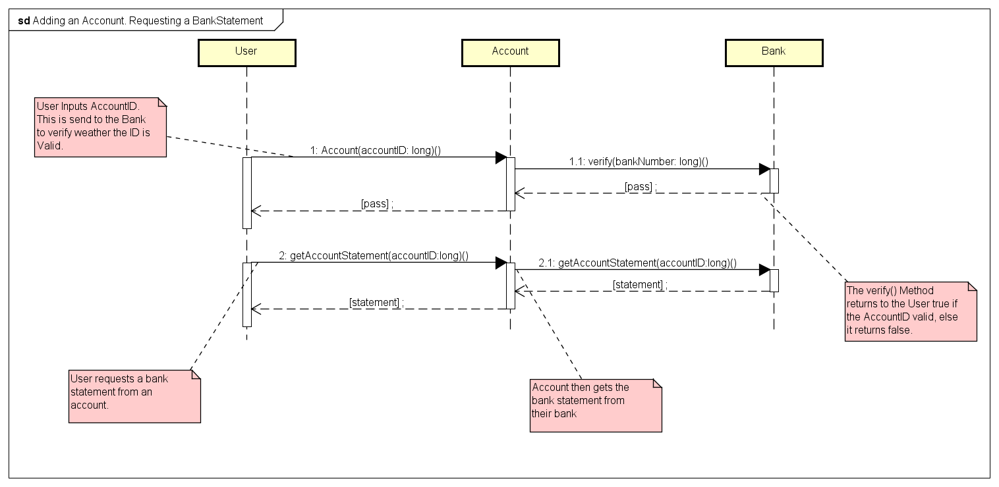
Adding an account sequence diagram

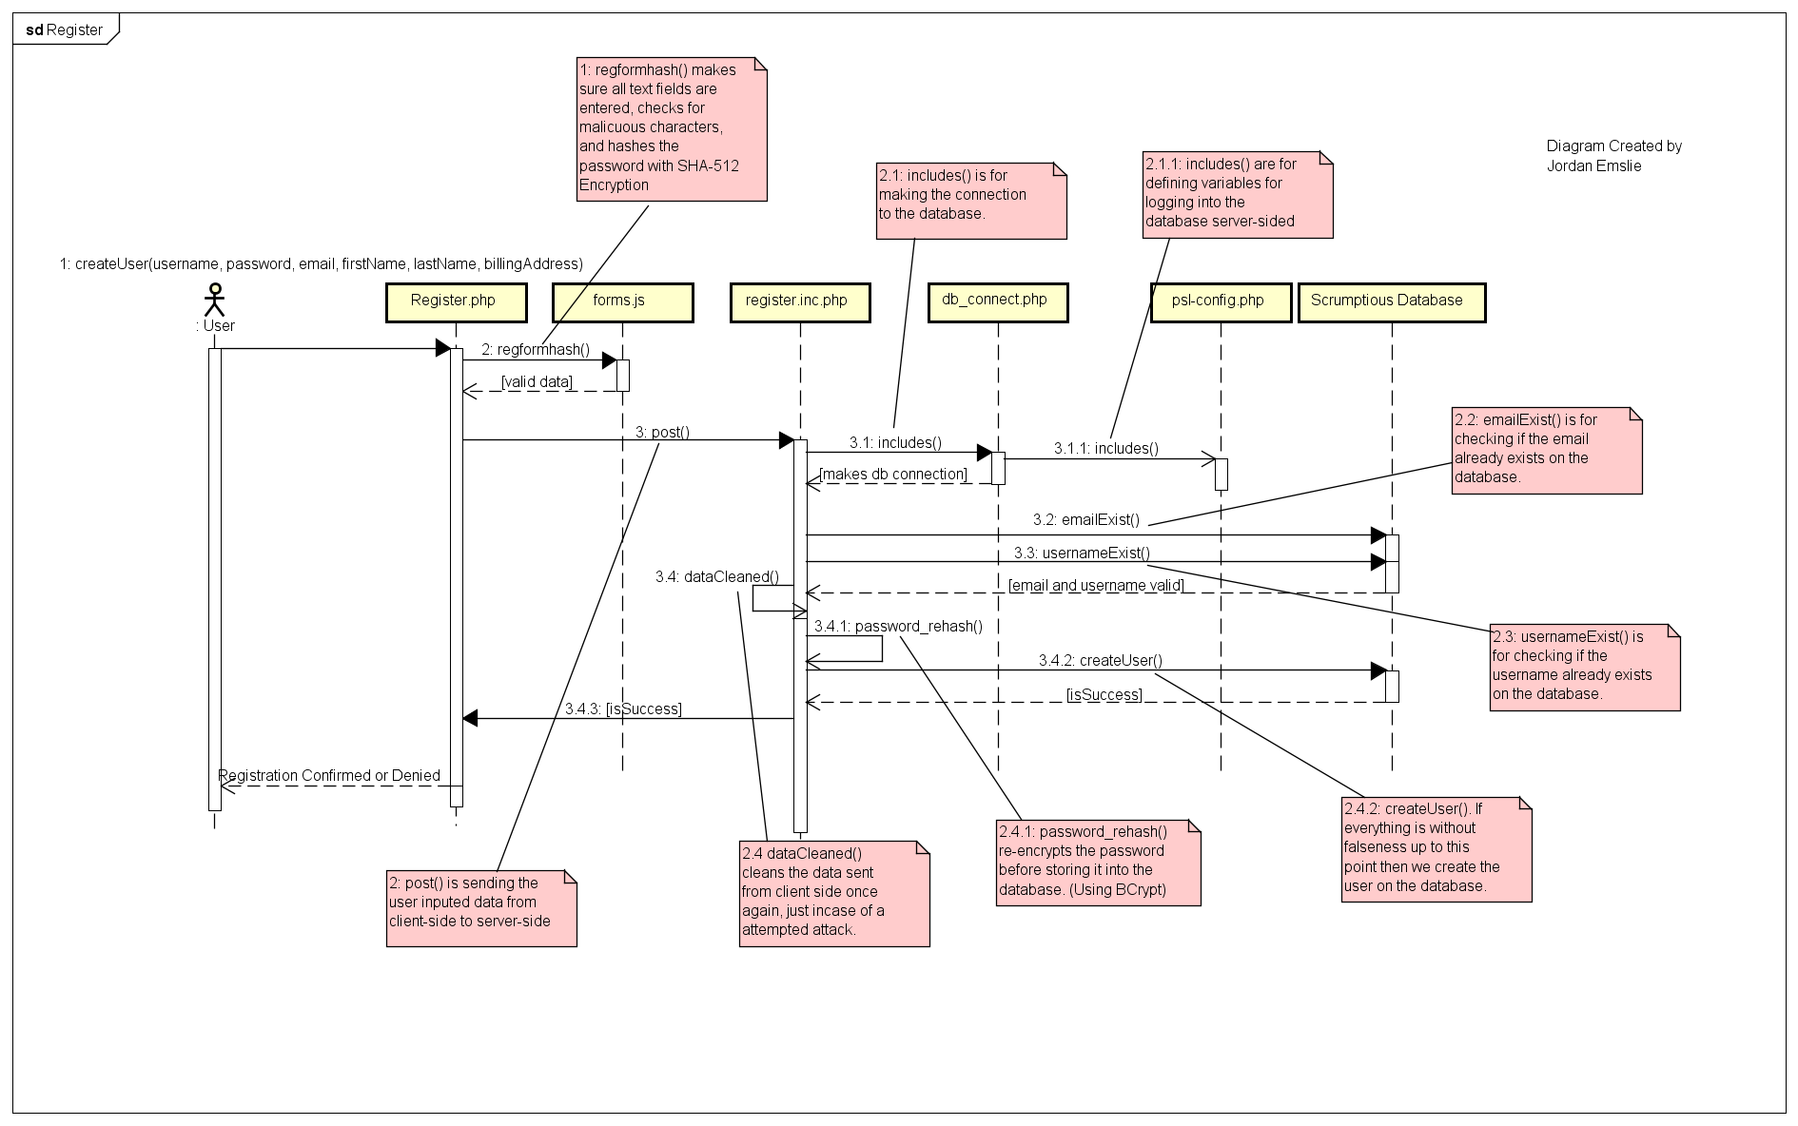
Register User Sequence Diagram

Transaction process sequence diagram
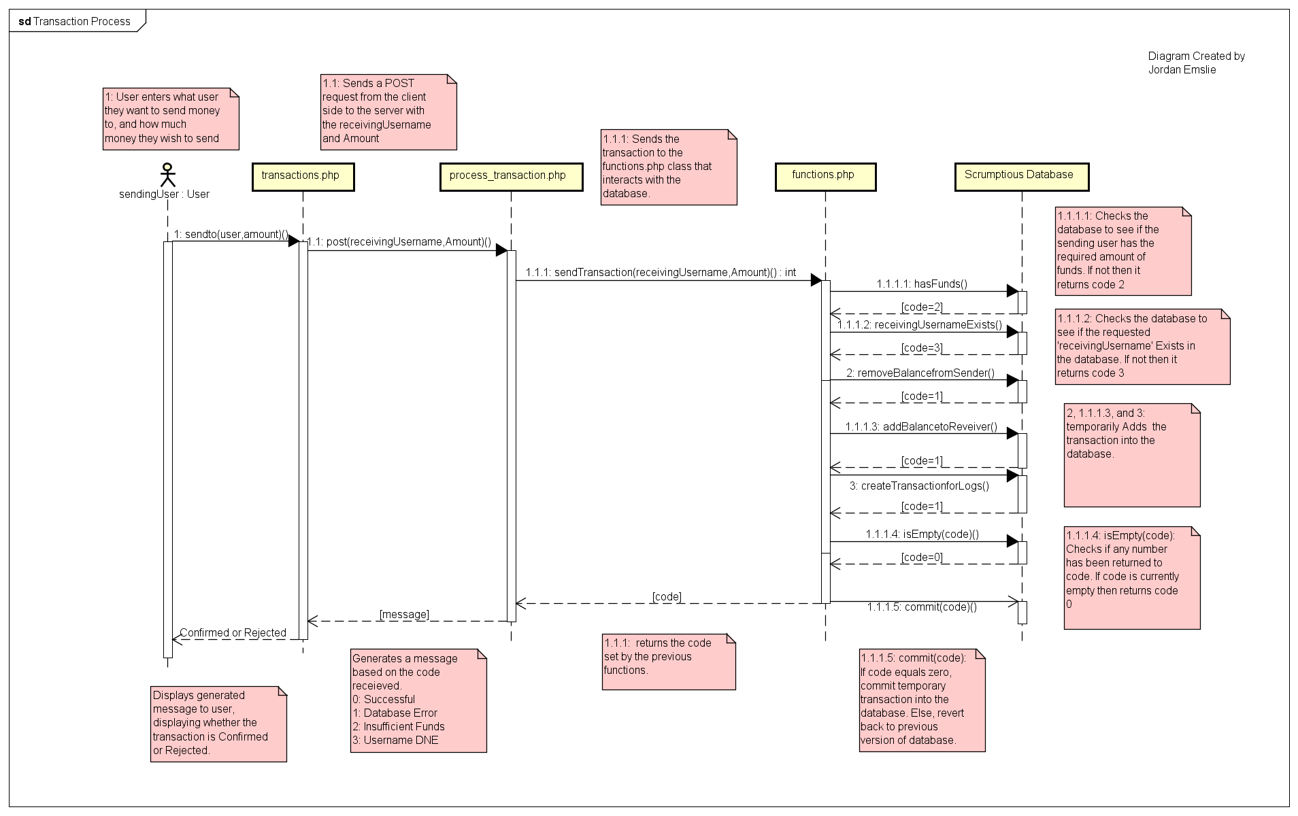

Activity Diagram

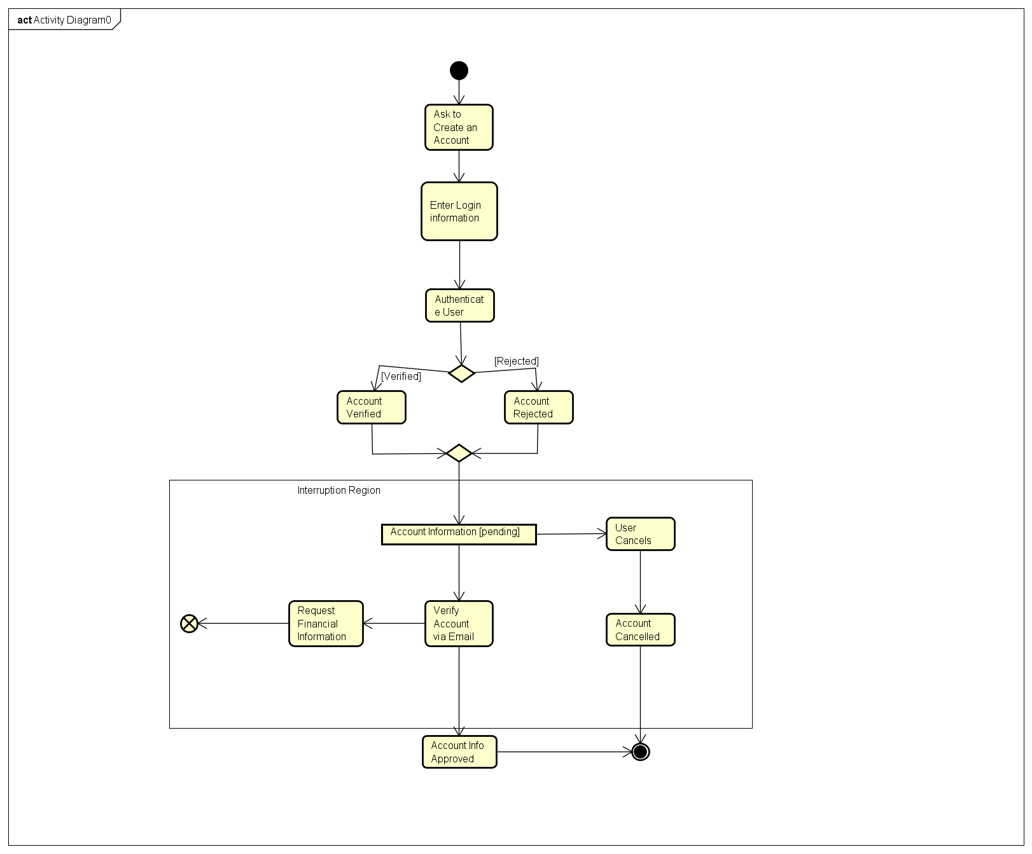

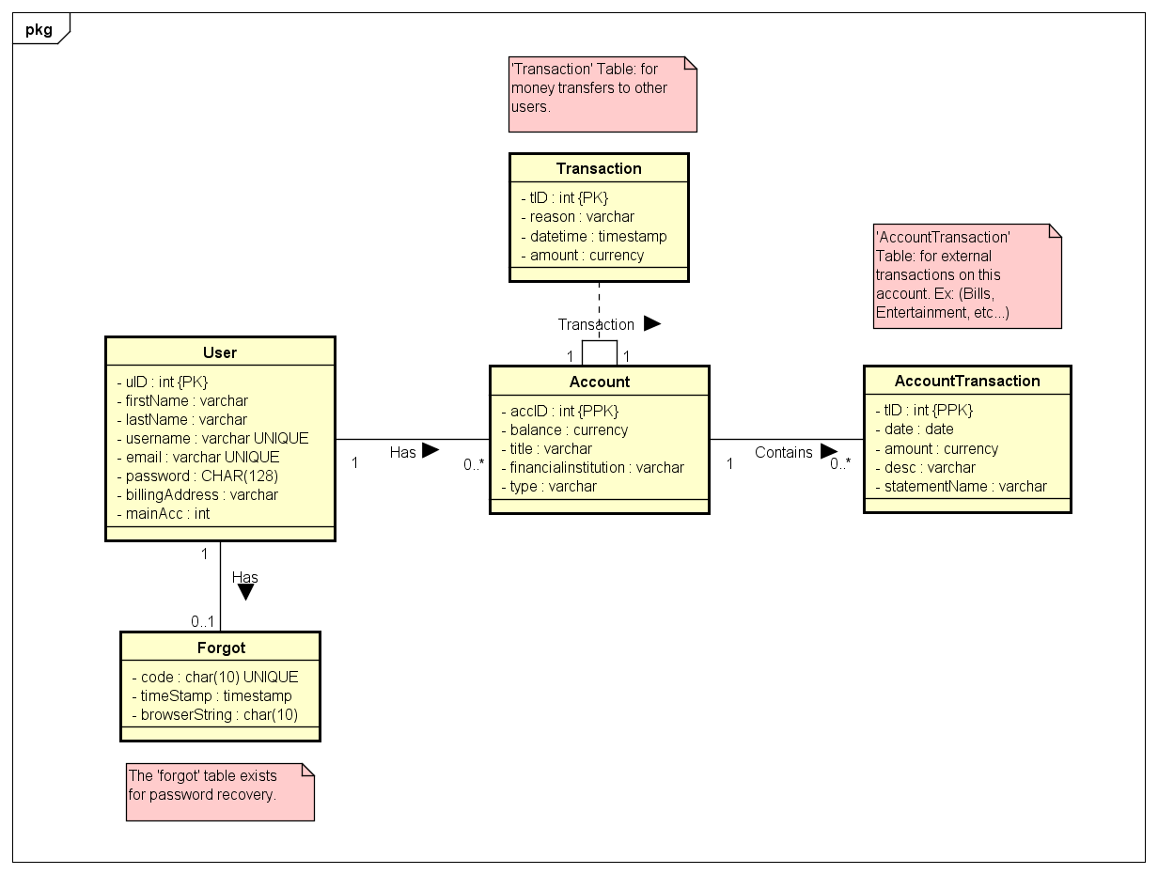
UML Class Diagram

Use Case Diagram

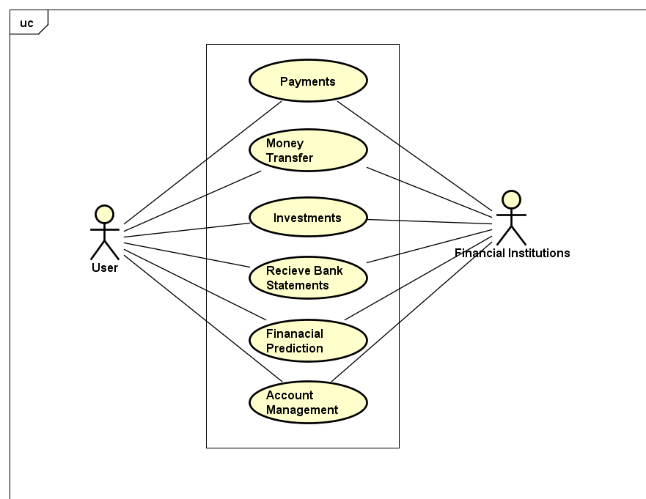

Appendix C: To Be Determined List
- User Interfaces

